# How data will be sent from phone to web server

The two mains ways which you can send data from a web server are through WIFI and through using your mobile data. This will explore both and the advantages and disadvantages of both as they are quite similar in many ways.

## Wireless Connection

Where you are using WIFI you will need to make sure that you are connected to the internet to be able to send the data to a web server.

### Advantage

* You can send the data from anywhere with WIFI if you have a stable internet connection which you are connected to.
* Usually a cheaper option to sending data than a mobile connection.
* Can have more than one person sending data as not bound by amount of ports available to you.

### Disadvantages

* Isn’t as secure as someone on the same WIFI connection can intercept the data.
* Need to be connected to the internet first to be able to send the data to the server otherwise you can’t.
* Connection can be obstructed by things such as thick walls or everyday household items.

## Mobile Data Connection

This method of using your phones mobile data to send data which will likely be affected by your sim tariff. With this method, you will likely be using a 3G or in some cases a 4G connection to send the data to the server. 3G is simply a type of mobile phone technology that allows you to make calls, texts and access the internet. 4G is better than 3G as it means more data can be transmitted faster.

### Advantage

* Usually more secure than conventional WIFI connection.
* Hassle free as you don’t have to mess around with wires, modems etc.
* Don’t have to mess around with setting anything up such as logging into a WIFI connection or entering passwords to gain access as its usually already set up for you with your sim.

### Disadvantages

* Can be unexpected cost with using just mobile data as you may think your just using it to send data to a server though in the background it could be downloading updates for your hundred apps that need to be updated.
* You usually have a limit and these can range to 500mb to 20GB depending on which you buy. Usually with phones you may be on pay as you go or have a monthly contract where you are allocated an amount of data you can use usually around 1GB-5GB
* Connection timeouts can usually occur more times than with using WIFI depending on the network you are with and the support the provide to accessing 3G and 4G connections. Sometimes may find yourself using 2G connection and sending data may take forever.

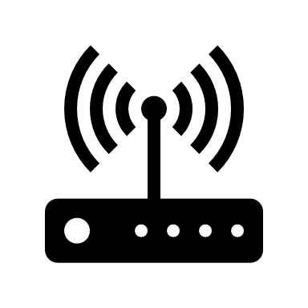

**Web Server**

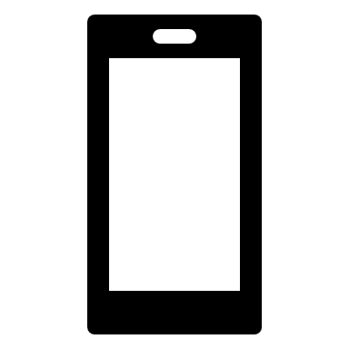

**Phone**

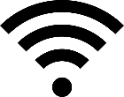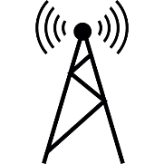

**Wireless connection either via WIFI or mobile network**